[](https://ok.ru/dk?cmd=PopLayerPhoto&st.layer.cmd=PopLayerPhotoOuter&st.layer.type=GROUP&st.layer.revNav=off&st.layer.limitedUi=false&st.layer.sphotoIds=863915969800%3B863915974152%3B863915973896%3B863915973640&st.layer.showNav=on&st.layer.photoAlbumId=53866785800200&st.layer.epm=off&st.layer.photoId=863915969800&st.layer.opl=off&st.layer.navStartPhotoId=863915969800&st.layer.sbd=off&st.cmd=userMain&st._aid=GroupTopicLayer_openPhotoLayer)

[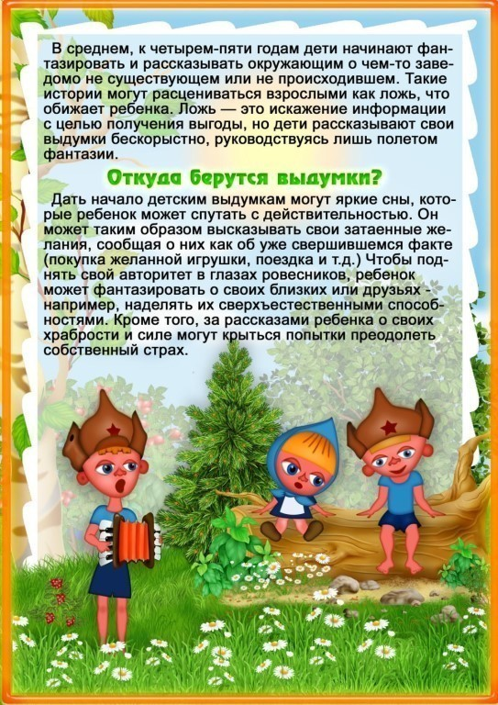](https://ok.ru/dk?cmd=PopLayerPhoto&st.layer.cmd=PopLayerPhotoOuter&st.layer.type=GROUP&st.layer.revNav=off&st.layer.limitedUi=false&st.layer.sphotoIds=863915969800%3B863915974152%3B863915973896%3B863915973640&st.layer.showNav=on&st.layer.photoAlbumId=53866785800200&st.layer.epm=off&st.layer.photoId=863915974152&st.layer.opl=off&st.layer.navStartPhotoId=863915974152&st.layer.sbd=off&st.cmd=userMain&st._aid=GroupTopicLayer_openPhotoLayer)

[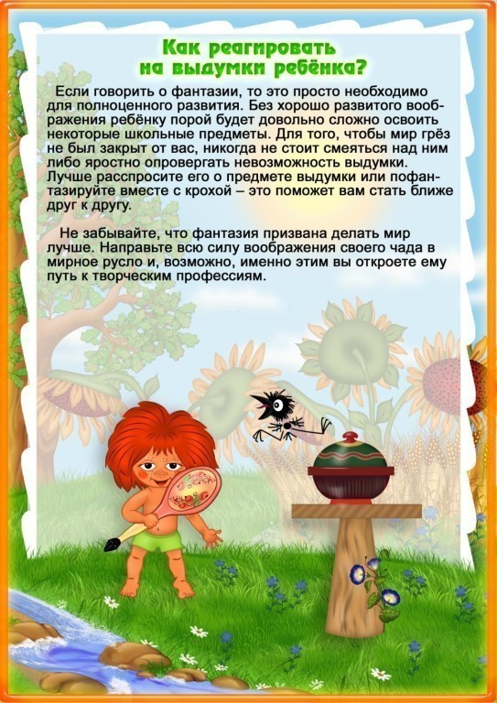](https://ok.ru/dk?cmd=PopLayerPhoto&st.layer.cmd=PopLayerPhotoOuter&st.layer.type=GROUP&st.layer.revNav=off&st.layer.limitedUi=false&st.layer.sphotoIds=863915969800%3B863915974152%3B863915973896%3B863915973640&st.layer.showNav=on&st.layer.photoAlbumId=53866785800200&st.layer.epm=off&st.layer.photoId=863915973896&st.layer.opl=off&st.layer.navStartPhotoId=863915973896&st.layer.sbd=off&st.cmd=userMain&st._aid=GroupTopicLayer_openPhotoLayer)

[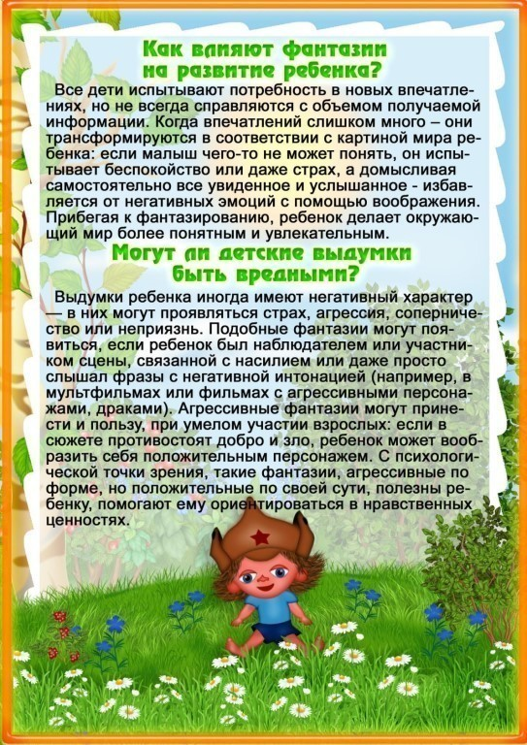](https://ok.ru/dk?cmd=PopLayerPhoto&st.layer.cmd=PopLayerPhotoOuter&st.layer.type=GROUP&st.layer.revNav=off&st.layer.limitedUi=false&st.layer.sphotoIds=863915969800%3B863915974152%3B863915973896%3B863915973640&st.layer.showNav=on&st.layer.photoAlbumId=53866785800200&st.layer.epm=off&st.layer.photoId=863915973640&st.layer.opl=off&st.layer.navStartPhotoId=863915973640&st.layer.sbd=off&st.cmd=userMain&st._aid=GroupTopicLayer_openPhotoLayer)